***ANUDIP FOUNDATION***

A Project Report on

**Online Examination System**

By

Batch: ANP-C7344

|  |  |
| --- | --- |
| **Student ID** | **Student Name** |
| AF0368608 | Divya Vishwanath Swami |

**Under the Guidance of**

Mrs. Rajshri Chandrabhan Thete

**Online Examination System**

Computerized and online systems have been increasing in every aspect of education. Information Technology plays a very important role in nowadays education. Computers and internet have made dramatic changes in the education system. Information technology enables institution of high learning to save time and money, and allow the delivery of education with easiness, anywhere, and anytime. Paper based books are replaced by online and off-line applications. With computer software, we can be able to have access to huge databases of information. This gives fundamental change to the education. The system helps students to take examination. It helps also lecturers to upload the questions and answers in the database and they can see the students who fail or pass the exam.

**Entities:**

* Project Planning

➢ Requirements Design

➢ Design

➢ Development

➢ Integration and Testing

➢ Installation and Acceptance

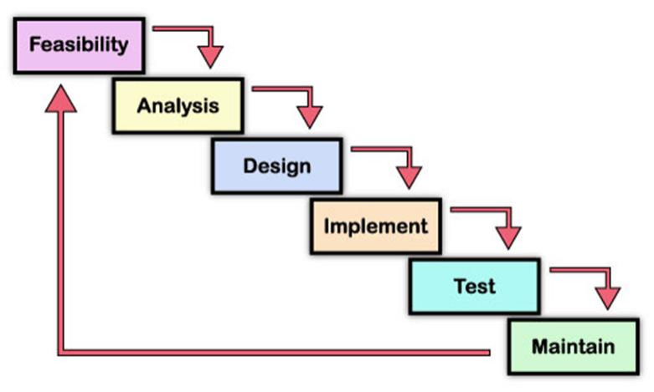

**VARIOUS ENTITIES:**

1. **Software Requirement Specification**

* Functional requirement
* Software product features
* Login/Logout
* Register
* Upload
* Select
* Non-functional requirement
* Reliability
* Availability
* Security and Safety
* Maintainability
* Portability
* Performance
* Flexibility
* Efficiency
* User Friendliness

1. **Users:**

* Field Name
* Username
* Password
* Email
* Mobile Number

1. **Questions Answers:**

* Field Name
* Subject
* questions
* Choice1
* Choice2
* Choice3
* Choice4
* Correct Answer

1. **Result:**

* Field Name
* ID
* Percentage
* Grade

**Use case diagram**

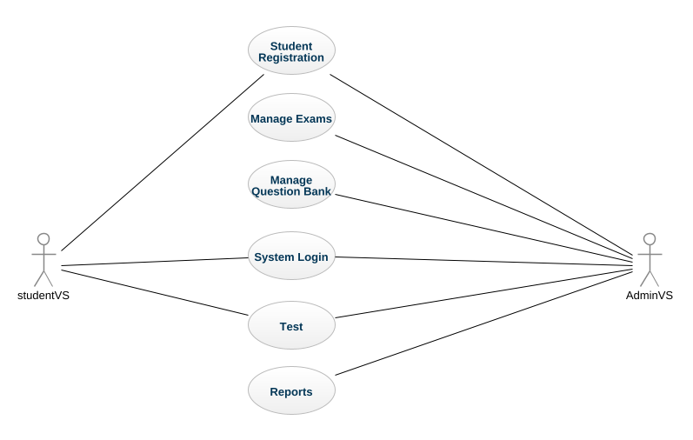

**System flowchart**

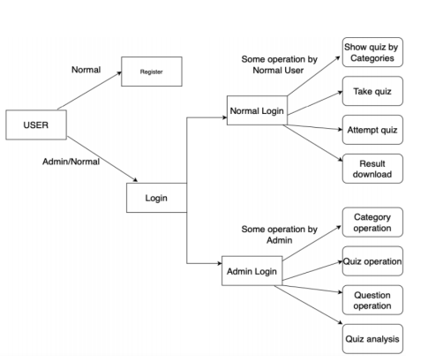

**Entity Relationship Diagram**

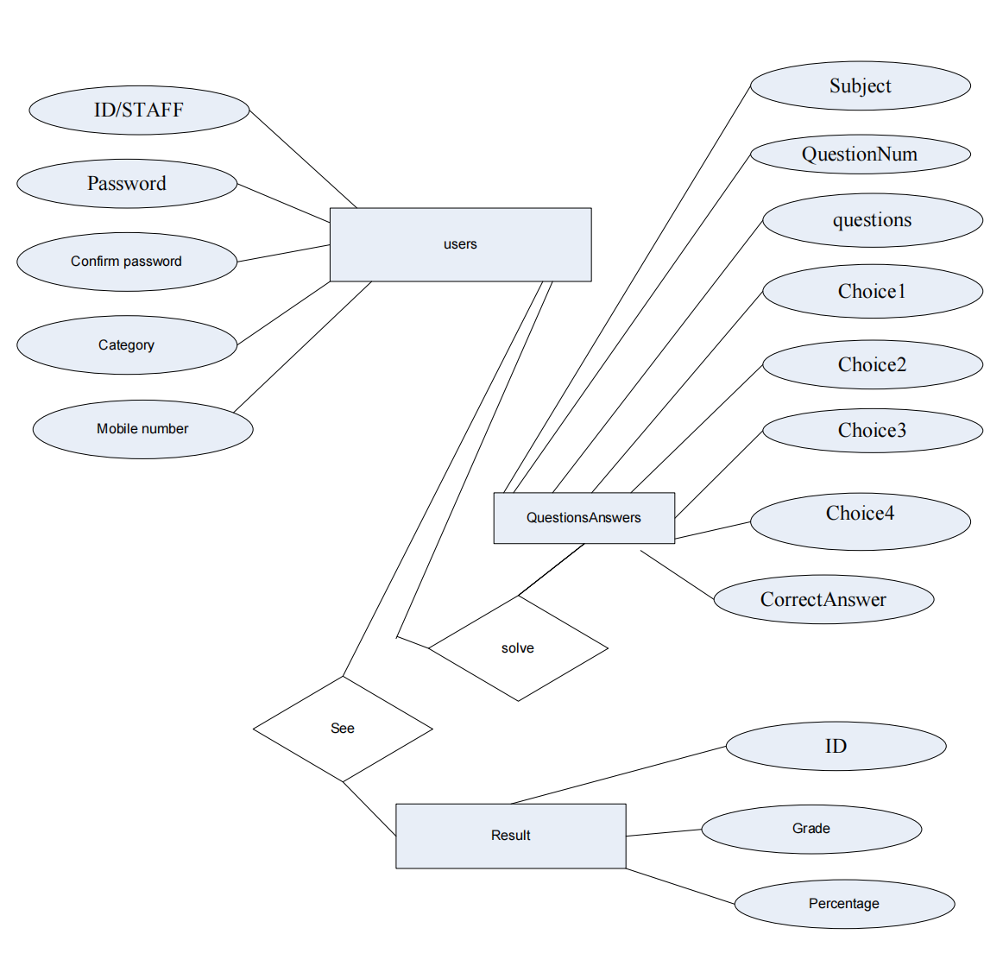

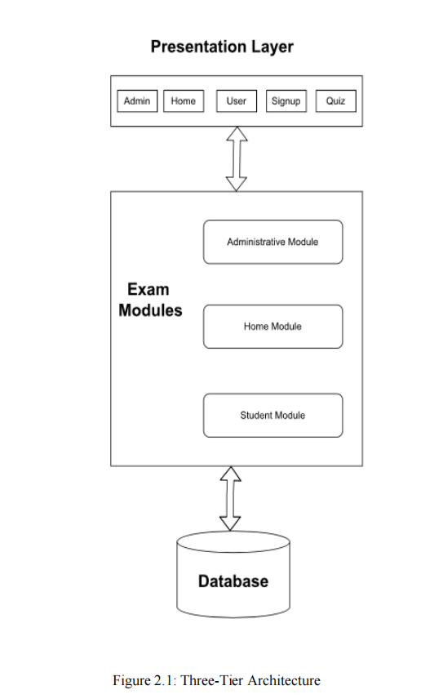

**Technical Requirements**

**Hardware**

Windows requirements Mac requirements Linux requirements Operating system Windows 8 - 10 or later mac OS Sierra 10.12 or later 64-bit Ubuntu 14.04+, Debian 8+, open SUSE 13.3+, or Fedora Linux 24+ Processor Intel Pentium 4 or later Intel

* Intel Pentium 4 or later
* Screen resolution 1280x1024 or larger
* Application Window Size 1024x680 or larger
* Internet connection required.

**Software**

Java is a popular programming language for creating a wide variety of applications, including web applications. Here are some tools and frameworks that are commonly used for developing web applications in Java

**Spring:** Spring is a popular framework for building web applications in Java. It provides a range of features, such as dependency injection, web MVC, and security.

**Hibernate:** Hibernate is an object-relational mapping framework that allows developers to map Java classes to database tables. It simplifies database access and reduces the amount of boilerplate code required.

**Struts**: Struts is a web application framework that follows the Model-View-Controller (MVC) architectural pattern. It provides a range of features for building web applications, such as form handling and validation.

**CONCLUSION:**

Online examination system is the best compared to paper-based exam. The automated system helps students and lecturers to save time and makes the process faster. It saves space since answers papers will not be used. With a user friendly system that has security, integrity and the database is neither inconsistent nor redundant.